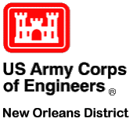

**ENGINEERING DIVISION**

Technical Workshop

Location: Room 304

Date: October 20, 2022 (Thursday)

Time: 11:30 a.m. – 12:30 p.m.

Topic: **"Ecological Hydrology – Blending Hydrologic, Water Quality, and Biotic Processes”**

Speaker: Todd E. Steissberg1 and Billy E. Johnson2

ERDC1 and LimnoTech Inc2

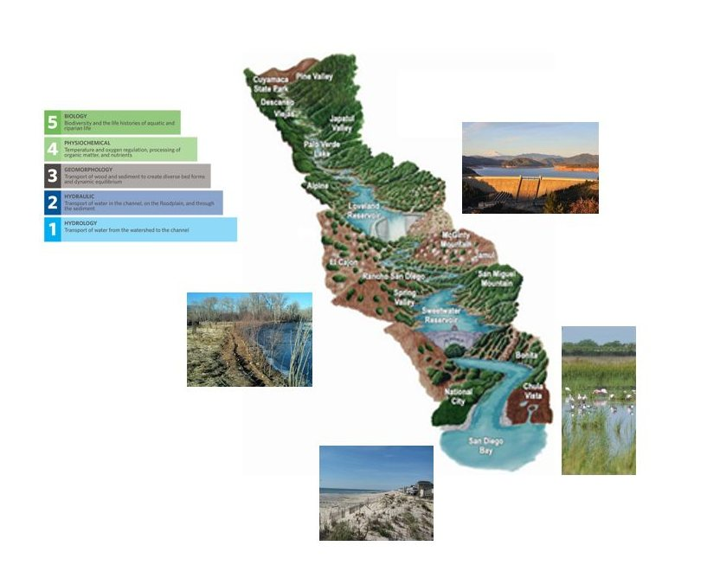

**This talk will focus on defining Ecological Hydrology, discussing the Planning Process for Implementing Eco-Hydrology Projects, and presenting Current ERDC Design Tool Development to support Eco-Hydrology Projects on a System Wide Basis**